**GlassCasino Presentation Appendix**

# Figures

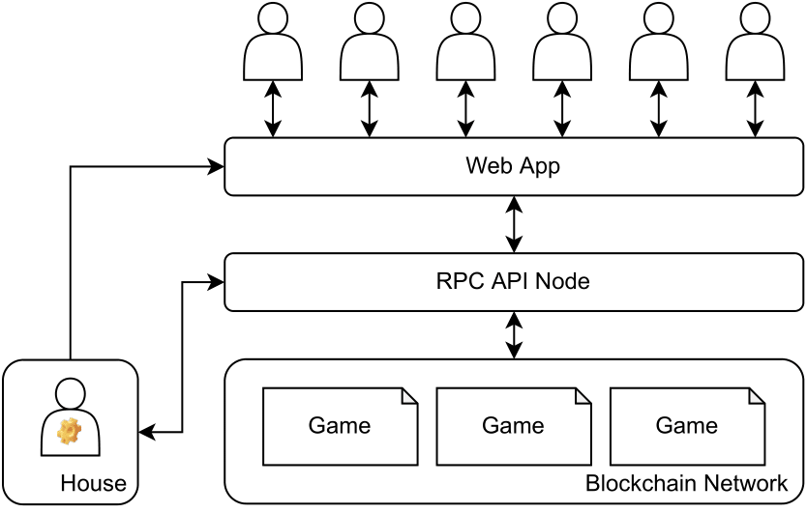

Figure - The project architecture showing smart contracts deployed to a blockchain and how a user or automated user like the admin can interface with said contracts.

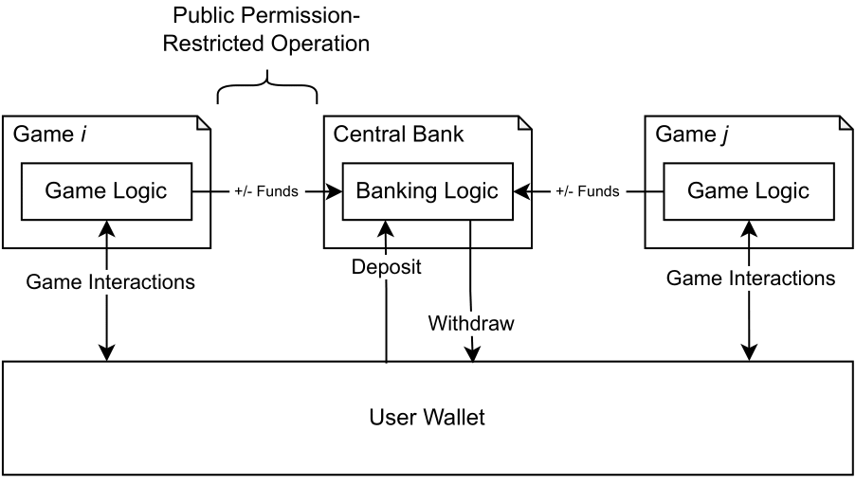

Figure - Single-contract, low-cost on-chain central banking and its interaction with game smart contracts and the user.

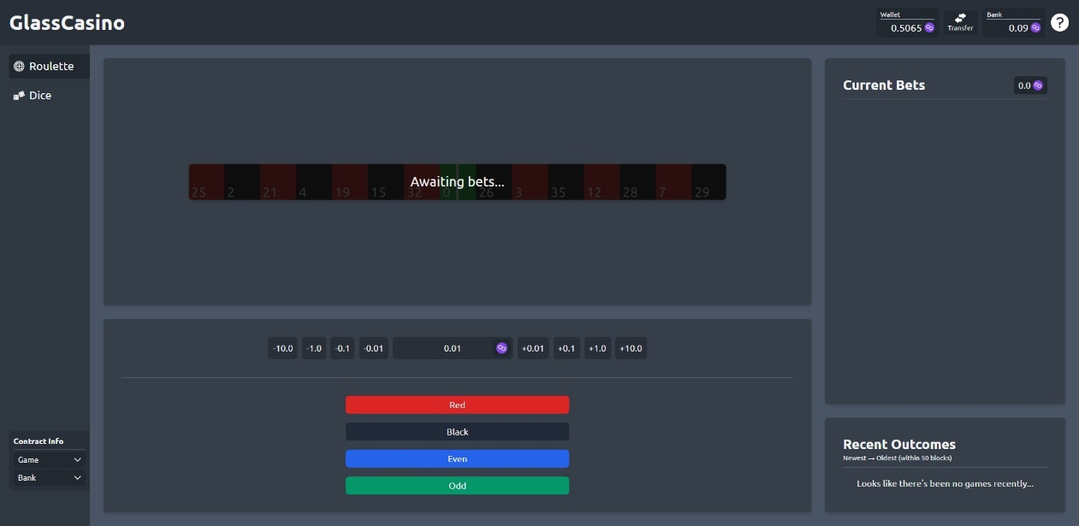

Figure – Example of the completed roulette user interface on a 1920x1080 desktop viewport.

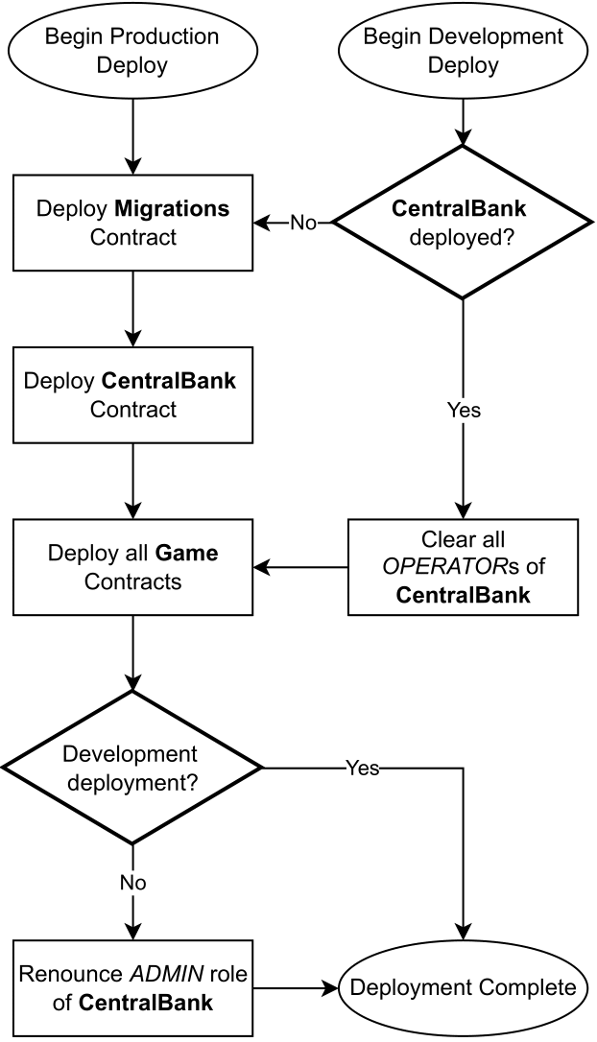

Figure – Deployment chain for game, banking, and migrations smart contracts.

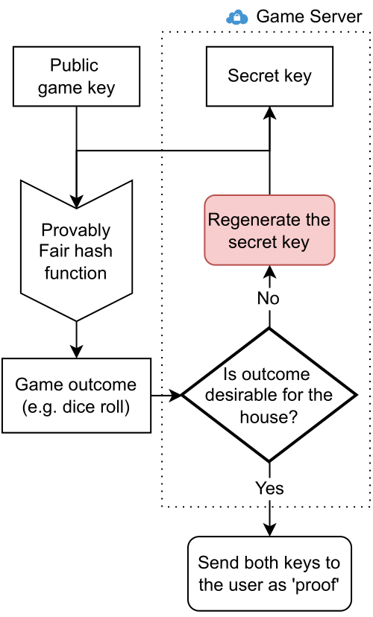

Figure – Feedback loop that centralized iGaming platforms can use to produce malicious yet ‘provably fair’ game outcomes (left) compared against ChainLink VRF’s on-chain random value and its proof (note that ChainLink VRF takes ~10 blocks to fulfill randomness as it uses future block headers as part of its seed).

# Tables